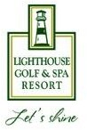

MEDIA PACK

CONTENT
- Venue Overview
- Golf Course
- Facilities
- Golf Property
- Golf Tourism
- The Destination
- Climate
- Getting There

Contact details:
Lighthouse Golf & Spa Resort Balchik | Bulgaria
E : info@lighthousegolfresort.com T: +359 882 060 588
W: www.lighthousegolfresort.com

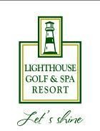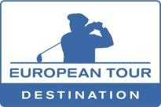

VENUE OVERVIEW
Lighthouse Golf & Spa Resort is part of the exclusive European Tour Properties network of world class golf venues.

Situated near the historical town of Balchik, Bulgaria, and 40km from Varna International Airport, the resort is at the heart of Cape Kaliakra’s signature Golf Coast, which is renowned for its lush, green landscapes and spectacular coastline. The venue’s par 71 Lighthouse course sits on top of towering white cliffs, commanding breathtaking views over the glittering blue Black Sea.

In addition to its signature 18-hole golf course designed by Major champion, Ian Woosnam, the venue comprises a stylish clubhouse, a golf academy with superb practice facilities, plus a state-of-the-art Spa and Wellness Centre of some 3000m². Various restaurants and bars, a sports centre with tennis courts and football pitch, and a sandy stretch of beach with its own bar, round off the extensive list of facilities available at Lighthouse Golf & Spa Resort.

The resort also offers a broad range of real estate opportunities, including luxury villas and stylish apartments with views to the golf course and the spectacular mountain landscapes.

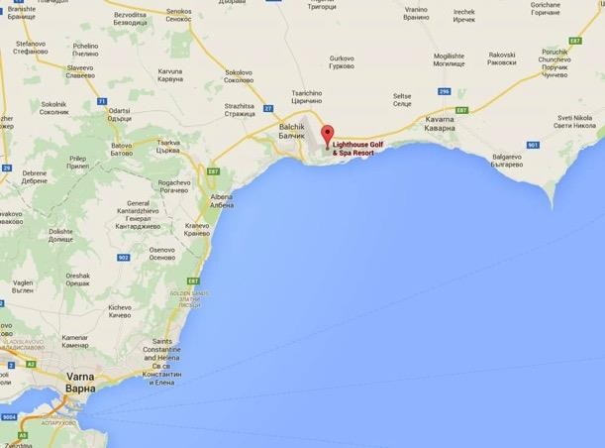

GOLF COURSES

LIGHTHOUSE GOLF COURSE

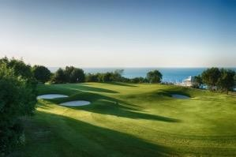
Opened in 2008, the Lighthouse Course capitalises on the stunning surrounding scenery and spectacular natural landscapes. Designed by 1991 Masters Champion and 2006 Ryder Cup captain Ian Woosnam, this par-71 Championship layout has a links-like quality.

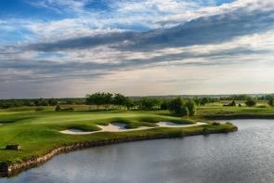
With fairways laid out around several pockets of residential developments and a routing that occasionally takes holes towards the cliff tops, the course provides a thrilling variety of golfing challenges
– ones that will test the professionals while offering truly enjoyable experiences for the amateurs.

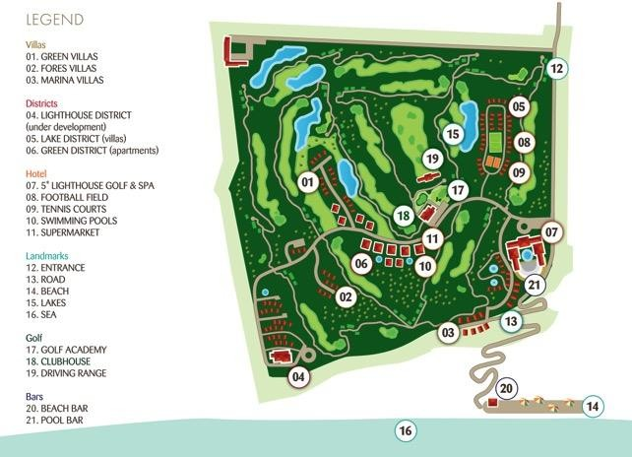
Measuring 6,747 yards, the Lighthouse Course boasts a fine set of five short holes, two on the front nine and three on the back nine – the best being the 164-yard 17th, where water protects the front right hand side of the green.

BLACKSEARAMA GOLF COURSE (2KM FROM THE HOTEL):

Endless sea view from 200 meters high to the magnificent and extremely diverse bay from Cape Kaliakra to Cape Galata - this is Blacksearama, the first championship signed golf course - 18 holes, par 72, length - 6648 meters - and the first completed Gary project Player in Eastern Europe.

From a flat terrain, a magnificent classical cliff-top links golf course is created, with intimacy at very each of the fairways and with greens, often exceeding the regular sizes. The whole design is fulfilled with respect towards the player, as it gives him/her a maximum of the chance for a good round at a high-class golf course, where the wind - as it is usual when close to the sea - is often a significant factor
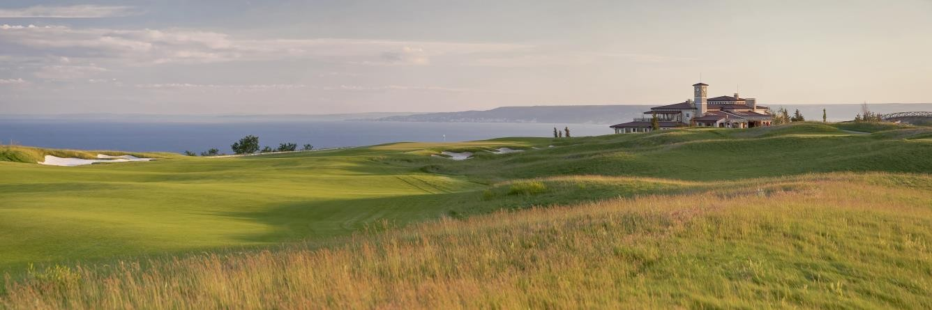

THRACIAN HILLS GOLF COURSE (6KM FROM THE HOTEL):

Surrounded by jagged coastal cliffs and the endless blue of the Black Sea, the "signed" and designed by Gary Player 18-hole Thracian Rocks Golf Course is one of the most dramatic golf courses on earth.

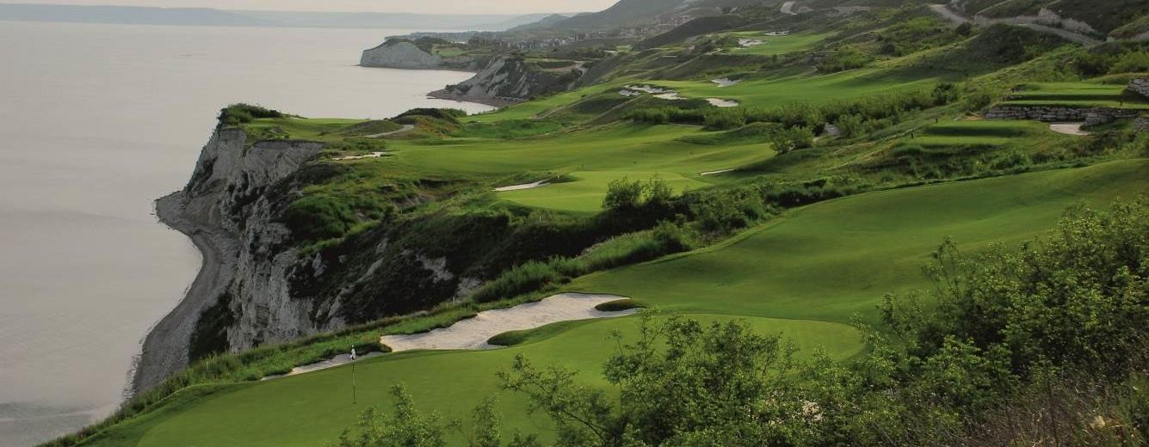
The 18-hole Gary Player Signature designed Championship golf course dominates the resort, hugging the clifftops for 4.5 km of rugged terrain above the sea, offering dramatic sea views from every hole. Recognized as one of the most visually outstanding courses on Earth, Thracian Cliffs is masterfully sculptured hole by hole to fit perfectly into the cliffs and the natural landscape.

FACILITIES
Lighthouse Golf & Spa Resort offers visitors a rich choice of options, be they sports lovers, foodies or culture aficionados.

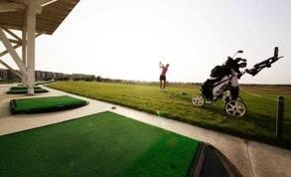
Golf Academy and Practice Facilities

The Lighthouse Golf Academy has been built to create a relaxed and friendly atmosphere in which to take up or improve your game. Comprising a covered driving range, the Academy offers:

  - 300m, 24 bay covered driving range
  - Short game area
  - Putting green, chipping greens & bunker area
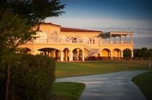
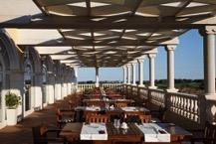
  - Golf instruction in English, Romanian, German
  - Club rental

Clubhouse
With wide-open terraces that dominate its upper floor, the clubhouse offers great views over the 18th green and the 1st tee.
On its lower floor the clubhouse offers a fully equipped pro-shop, two spacious changing rooms and the 19th Hole bar with patio and direct access to the golf course, which is a perfect place to relax after a round. The lively bar is ideal for early dinner or a late supper with a variety of snacks, grills and salads to choose from. The bar also offers a wide range of Bulgarian and International beers and wines.

On the upper floor there is a private members’ lounge, several multipurpose function rooms and a spacious lobby, plus the Prestige restaurant.

Additional Sporting Facilities

  - Tennis Courts –The resort offers two floodlit artificial grass courts, located across from the hotel in the Revecca sports centre.
  - Mini Football Field – a mini Astroturf football field is also in the Revecca sports centre. The field is floodlit for evening games.
  - Bike Rental – Lighthouse Golf & Spa Resort guests are able to rent bicycles from the Revecca sports centre to enjoy the numerous cycle paths around the resort, suited to any age or ability.
  - Jogging paths – the 40,000-acre resort is replete with private routes that wind down through the cliffs, all offering joggers a stunning Black Sea panorama.

  - Yoga classes - A morning sun salutation made on one of our panoramic terraces, along with the sound of the sea will make you start the day in a unique manner.
  - Shooting - On site you can find a shooting range where you can practice skeet shooting. Nicely located under the cliffs the range gives you the opportunity to experience a new and exciting sport. Personal coach is there to assist you and guide you.

Mini-golf
  - Petanque Field

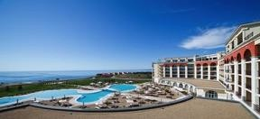
Hotel

The five-star Lighthouse Golf & Spa Hotel is the latest addition to the resort. Elevated on its own plateau, it offers spectacular views both of the golf course and of the Black Sea. Featuring contemporary and elegant architecture, it is the first Resort hotel of its kind on Cape Kaliakra’s Signature Golf Coast.

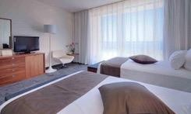
Opened in 2011, the hotel offers 180 double guest rooms and club suites and 4 exclusive penthouses, designed to cater equally for holidaymakers and business travellers, featuring modern design, comfort and space. Light colours such as white, cream and gold, symbolise the resort’s year-round sun. At 30m², the rooms are some of the largest in the area and all have private terraces overlooking the course or the sea.

Located at the heart of Cape Kaliakra golf coast, our newly created Penthouse collection is tastefully decorated with modern touches and Asian and French styles. Each property is appointed a private butler. Wake up to spectacular views of the Black Sea coast and enjoy a morning swim in the top floor infinity pool to prepare for the day ahead. The floor-to-ceiling windows allow you to spot pristine nature and unbelievable coastline. With ample space for private parties, you’ll have all the lavish amenities needed to create an unforgettable holiday experience.
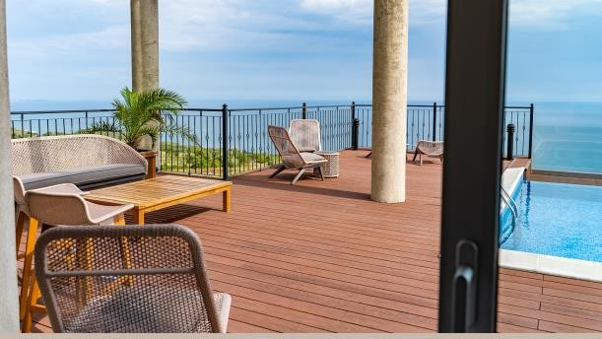
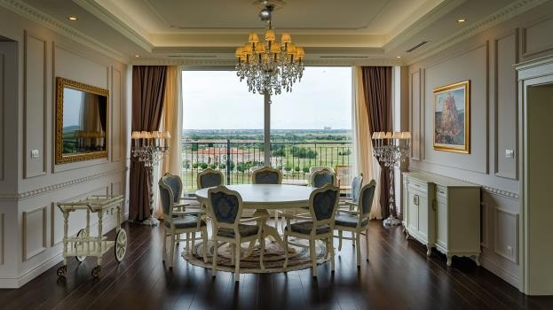

Fitness Centre

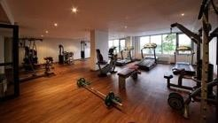
The Lighthouse Fitness Centre is a fully-equipped gym with a view out towards the golf course. Located in the main hotel building, it has a full range of cardiovascular, free-weight, cable and kinesis equipment.

Kids’ Facilities

On site you can find:

  - Games Room – with various video games, darts, billiards and mini football
  - Indoor Kid’s Club for the younger children
  - Outdoor playground
  - Mini golf
  - Petanque Field
  - Weekend and Summer Animation Program with various sports and educational games and activities

Spa & Wellness Centre

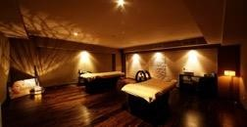
The Lighthouse Spa and Wellness Centre spans an area of more than 3000m². On the lower floor is a steam bath, Turkish bath, Finnish sauna, Infrared sauna, adventure showers, relaxation area, Jacuzzi and heated indoor pool with mineral water. On the upper floor there are seven individual massage rooms, each suited for couples’ treatments. Holistic health and beauty treatments blend Eastern and Western philosophies and include Ayurveda treatments.

Restaurants & Bars

The Lighthouse Golf & Spa Resort offers a great range of 5-star traditional and international cuisine. Daily specials use local ingredients, from the fish of the Black Sea and the Durankulak Lake to local, organically- grown eggs.

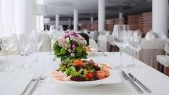
Dining options include:

  - Alexandra (main restaurant) – offers international cuisine in a stylish-yet-relaxed atmosphere, with both inside and outside seating. The restaurant is located in the Lighthouse Golf & Spa Hotel main building.

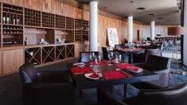
  - Le Passage (à-la-carte restaurant) – This luxurious gourmet restaurant offers a variety of fresh fish and seafood. The menu consists of exquisite dishes combining the tastes of the Mediterranean with a wide selection of shellfish, grilled fresh fish, oysters and caviar, accompanied by the very best wines and spirits.

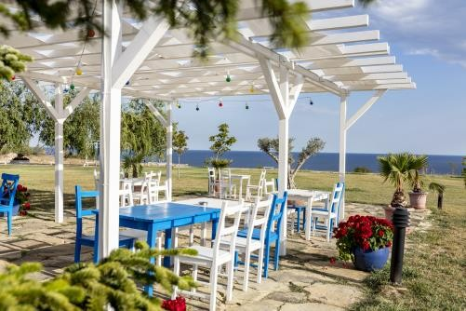
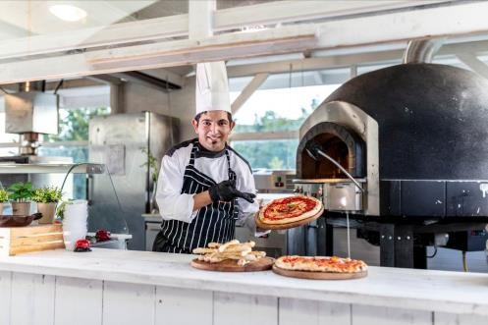
  - “The Greek” Tavern – the small restaurant is cosily placed outdoors by the main hotel’s pool and offers relaxed al fresco dining with some of the most traditional Greek specialties such as Greek salad, grilled haloumi cheese, tzatziki, Dolmadakia and keftethes. It operates during the summer months and offers a la card menu and dine-around option for guests on All-inclusive.

  - 19th Hole Bar and Grill - the perfect place to kick back and relax after a round of golf. This lively bar located in the Clubhouse is ideal for lunch or early supper and offers variety of light snacks, grills and salads.

There are five main bars at the Resort:

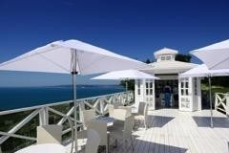
  - ‘Shiv’s’ Sky Bar – This is the newest addition to the resort offering breathtaking views, cold and refreshing drinks and light snacks. Do not miss to visit it and enjoy the sea view whilst seeping on your morning coffee or why not your afternoon cocktail. When you are ready for a refreshing drink with amazing view and intimate conversation is time to visit our Shiv’s Sky bar located at the Lighthouse Golf Course.
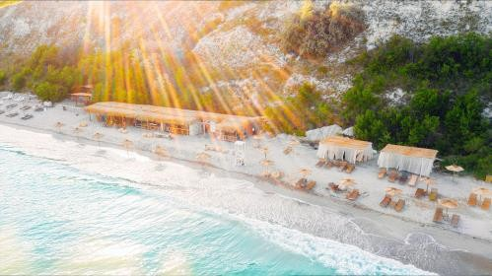
  - Heros Beach Bar – the beach bar offers a wide selection of delicious cocktails, refreshments and aperitifs for all those who enjoy relaxing in the sun. It is a perfect place to take a break from your beach activities and have a drink and a light salad or an appetizing meal of grilled vegetables and meats. Freshly prepared specialties, local Black sea mussels and fresh fish served up and go perfectly with a cold beer.

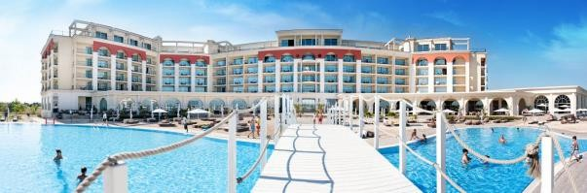

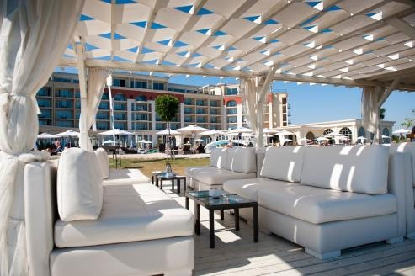
  - Infinity Pool Bar – next to the hotel’s outdoor pool, the Infinity Pool bar offers amazing views towards the Black Sea. Here, guests can enjoy a Mojito cocktail or a platter of fresh seasonal fruits.
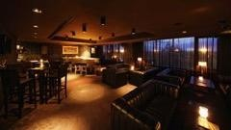
  - Social Club Whiskey Lounge – Are you in the mood for some light music while sipping on an exotic cocktail or an aged whiskey? Than Social Club Whiskey Lounge is the place to be for a fun night out with your loved one or friends. Conveniently located at the 5* Lighthouse Golf & Spa Hotel, the Whiskey Lounge is a lively place, popular with the guests of the golf resorts in the area with its cozy interior and pleasant music. You can also boost your spirits with live guest DJ mic or live music.
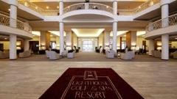
  - Lighthouse Lobby Bar –The Lighthouse Lobby Bar is the heart of the hotel & both spacious, light and open it offers a perfect setting for your morning coffee accompanied by our selection of homemade cakes whilst you sit, relax and plan your day. In the evening hours, the lobby turns into a lively meeting point where you can have some drinks before heading to your dinner plans. Our bar features an exceptional collection of cocktails and spirits.

Pools & the Beach

Lighthouse Golf & Spa Resort has a lagoon-shaped outdoor pool just in front of the hotel, as well as a 20x10m indoor pool, which offers a comfortable alternative when the weather is not so welcoming.

Located on the White Lagoon, approximately 5kms from Lighthouse Golf & Spa Resort, guests will find the sandy Heros Beach, which offers sun beds & parasols, water activities and a
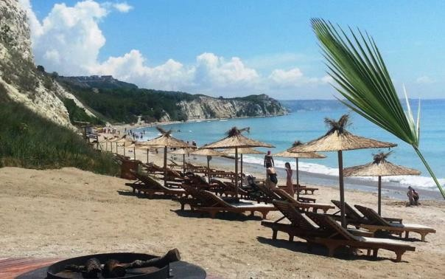
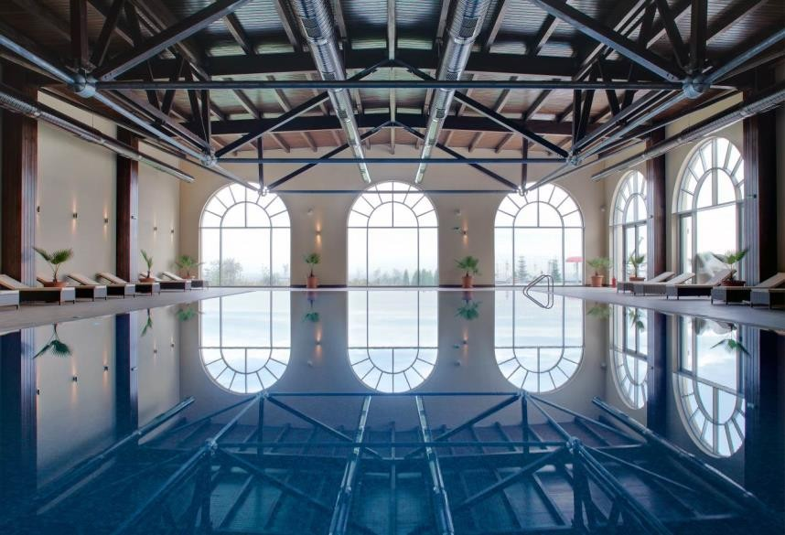
restaurant. A free shuttle service is provided for hotel guests in summer.

Meetings and events

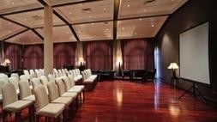
Lighthouse Golf & Spa Resort has various conference facilities and function rooms from the Poseidon Ballroom, which caters for over 300 people, to small meeting rooms of 20 people. All conference rooms are equipped with the latest technology. A selection of break-out rooms is available along with a spacious pre- event foyer, ideal for receptions and coffee breaks. The hotel also offers several outdoor venues, adjacent to the meeting rooms, suited for al fresco events.

GOLF PROPERTY
Lighthouse Golf & Spa Resort features a broad range of luxury properties including apartments, semi- detached houses and individual villas with unique designs. All properties feature modern architectural design and offer airy, light living areas, large balconies and beautiful private gardens.

Despite the economic crisis, record property sales have been registered. Just 40 minutes’ drive from Varna International Airport, the Lighthouse Golf & Spa Resort offers accessibility and exclusivity.
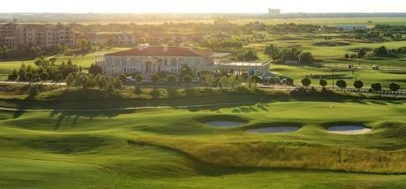

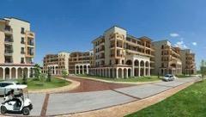
Real estate options at Lighthouse Golf & Spa Resort

  - Apartments
Studio, one and two-bedroom apartments, all furnished with flat screen televisions, cable TV and hi-speed web access, as well as fully fitted, Italian-style kitchens and security systems, are located in the resort’s Green District at the heart of the resort. Each apartment has views of the fairways or the sea.

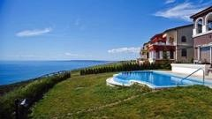
Villas
Villas can be found at various locations around the golf course and offer guests a variety of spectacular views including those of the Lighthouse course, the lakes, the surrounding forests, the sea or a combination of the above. The ‘Type G’ Villas are larger, two- floor countryside houses.

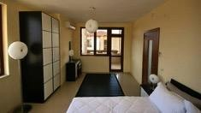
Semi-detached Houses
Semi-detached houses are located in the Forest & Green districts of Lighthouse Golf & Spa Resort, and have two or three bedrooms. Both options ensure panoramic views.

GOLF TOURISM

Traditionally, golf has not been one of Bulgaria’s most popular sports. In fact, there were no golf courses in operation before the turn of the millennium. In the last 12 years however, seven golf courses have opened.
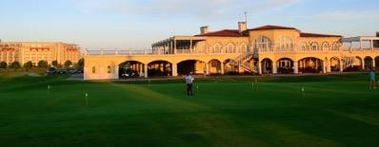

Even though golf is a brand new sport for Bulgaria, the developed venues are of world class quality and designed by some of the biggest names in golf course architecture, including Ian Woosnam, Jack Nicklaus and Gary Player. The continuing investment in golf in Bulgaria is a reflection of the ongoing buoyancy of the sector.

In 2011, the International Association of Golf Tour Operators (IAGTO) named Bulgaria the ‘Undiscovered Golf Destination of the Year’, an accolade that recognises the country’s potential as a golf location. A couple of years later, the first European Tour Event was hosted in Eastern Europe, in Bulgaria – the Volvo World Match Play Championship at Thracian Cliffs Golf Course.

Both events have helped validate the Cape Kaliakra region as a recognised destination for a golf holiday.

The golfing scene in Bulgaria is divided in two regions – the Cape Kaliakra Signature Golf Coast and the Sofia region:

Cape Kaliakra

The Cape Kaliakra Golf Coast is less than an hour away from Varna. Set near the border of Romania and overlooking the Black Sea, it is one of the most historic, scenic and culturally significant capes in Europe. In

addition to golf, it offers private beaches, luxury villas, historic fortresses, celebrated wildlife and the nightlife of coastal Varna within reach.

This coastline boasts three championship golf courses, the Ian Woosnam-designed Lighthouse Course and two Gary Player layouts – the spectacular Thracian Cliffs Course and the Blacksearama Golf Course, located next to Lighthouse Golf & Spa Resort.

Sofia Region

Bulgaria’s capital comprises three golfing venues which include the Pravets Golf Course and Spa, designed by Peter Harradine and less than an hour’s drive from the capital in the scenic lakeside town of Pravets; the two golf courses at Pirin Golf & Country Club, another Woosnam design, located in the Razlog-Bankso valley in the Pirin Mountains; and the St Sofia Golf Club, the first to open its doors to the public in 2000, situated 40km away from Sofia airport and 30km from Borovets, Bulgaria’s largest ski resort.

THE DESTINATION
Lighthouse Golf & Spa Resort is in the north east of Bulgaria, in the historical region of Cape Kaliakra, an easy drive up the coast from Varna, the country’s largest Black Sea coast city.

History & Culture

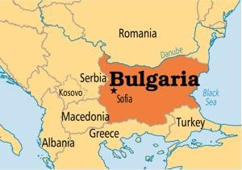
The country is at the crossroads between Europe and Asia, within an area that has been populated since antiquity. The Slavs and proto-Bulgarians were greatly influenced by the cultures of the Thracians, Illyrians and Greeks, and all peoples who resided on these lands – Thracians, Romans, Slavs, and Bulgarians – have contributed to the world’s cultural heritage. A large number of important golden artefacts have been found in this region, while the traditions, festivals, customs and rituals preserved by Bulgarians through the ages are evidence of the country’s spirituality and its dynamic lifestyle and culture.

Beaches

Bulgaria is famous for its sandy beaches, which can vary from lively and sports-facilitated strips to calm and beautiful campsites. Some offer traditional facilities like parasols, sun-beds and barbecue restaurants, while others offer more energetic activities, such as paragliding, surfing, diving, kiteboarding, bungee jumping and trampolines.

Recommended beaches around Lighthouse Golf & Spa Resort are:

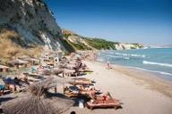
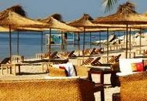

Heros Beach: white lagoon and the resort’s own beach – Surrounded by a beautiful white lagoon, this sandy beach is a short drive from Lighthouse Golf & Spa Resort and offers a variety of water sports and beach activities, including jet-skiing, scuba diving, sailing and fishing, as well as and private boat trips.

Bendida Beach – This unspoiled beach strip lies below the Thracian Cliffs Golf & Beach Resort golf course. It is a quiet cove, excellent for privacy and relaxation.

Albena – The Albena Resort lies some 20 km from Lighthouse Resort. Its clean, golden-sand beach strip is more than 3.5km long and up to 150m wide.

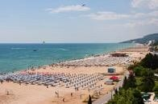
Golden Sands – This Blue Flag resort is well known for having one of the best sandy beaches in Europe.

Tourist Hot Spots

Some highlights include:
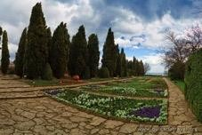
Balchik Palace and Botanical Garden
Constructed in 1924, the Palace was the former summer residence of the Romanian Queen Maria Alexandrina Victoria De Edinburgh. The Botanical Garden – another great landmark of the town – is within the borders of the residence.

Cape Kaliakra
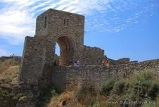
12km south east of Kavarna, is an oblong, narrowing rocky peninsula that juts out about 2km into the sea. The rich history, the well-preserved landscape plus the beautiful panoramic views, make Cape Kaliakra one of the most attractive tourist spots on the Black Sea Coast.

Aladzha Monastery
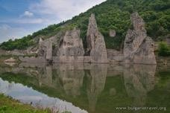
This is one of the few cave monasteries in Bulgaria where the different premises and their functions are clearly distinguishable. Premises are carved and arranged on two levels in a limestone rock that is almost 40m high.

Chudnite Skali / ‘The Wonderful Rocks’
This rock phenomenon is 4km from the village of Asparuhovo, municipality of Dalgopol, Varna. It was declared a natural phenomenon by Decree of the Council of Ministers in 1949.

Maritime Museum
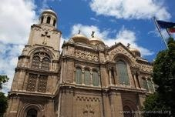
The Maritime museum was officially opened and consecrated on May 20, 1923. Located in the southernmost point of the Sea Garden, it was the first public maritime museum in Bulgaria.

‘The Assumption of Holy Mother’)
Situated on St. Cyril and St. Methodius square in the centre of Varna, this cathedral is a famous city landmark. The view from the belfry towards the city is splendid, but visitors must ascend the 133 stairs of the narrow caracol to see it.

Food and Eating Out

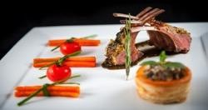
Bulgarian cuisine is representative of the cuisine of south-eastern Europe and shares a number of dishes with the Russian, Italian, Greek and even Middle Eastern cuisines. Many of the dishes are prepared according to traditional recipes handed down from generation to generation. The products for which Bulgaria is internationally known are yoghurt and white brine (feta) cheese. These are almost always present on Bulgarian tables in one form or another.

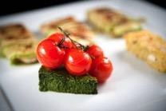
The most popular Bulgarian salad is the Shopska – a blend of tomato, cucumber, onions, peppers and feta. Soups and broths are also popular in the countryside. Excellent fish soups are served in the regions of the Black Sea. Some of the most popular Bulgarian dishes are grilled – meat balls, kebapches (minced meat with spices), grilled meat pieces, grilled sausages, and others. Various stews and dishes in clay pots are also a regular part of the Bulgarian cuisine. Various cold cuts and other meat delicacies are also popular.

Local Wines / Beers / Spirits

Bulgarian delicacies are usually accompanied by a Bulgarian wine and, thanks to the country’s unique climate and soils, a variety of grapes thrive in the region.

Bulgaria is also known for its Rakia. This light-coloured spirit is made from grapes and other fruits, depending on the region, which may vary from plums, apricots, figs and pears. A rose Rakia is distilled in the Valley of Roses (in Karlovo and Kazanlak), the home of Bulgaria’s oil-yielding roses.

CLIMATE
The maritime climate along the Black Sea coast is characterized by warm, sunny days from May to October with temperatures averaging 28°C and sea temperatures as warm as 25°C. The wettest months are June, October and December. Winter is cold, although milder than the interior of the country where the snow falls heavily. Summer is definitely peak tourist season on the Bulgarian coast, with its popular seaside resorts booming. Spring and autumn are also good times to visit because the weather is fairly mild.

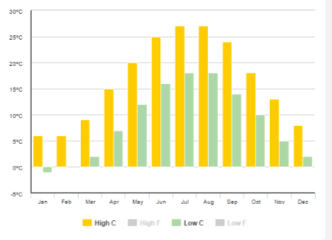

GETTING THERE

Lighthouse Golf & Spa Resort is reached by plane and by car.

By Air

The closest airport is Varna International Airport. There are many options for flights from across Europe and internationally:

  - Varna International Airport, Bulgaria – a 40-minute drive from Lighthouse Golf & Spa Resort
  - Constanta Airport, Romania – approximately one hour’s drive from Lighthouse Golf & Spa Resort

By Sea:

The closest port is located in Balchik, just a 10-minute drive from Lighthouse Golf & Spa Resort: http://www.port-balchik.com/en/

