

2023 FACT SHEET

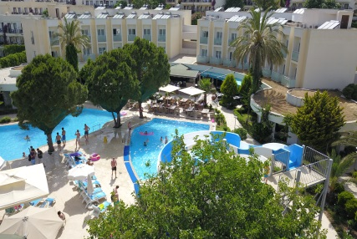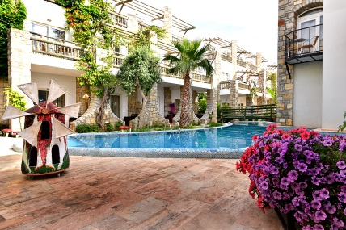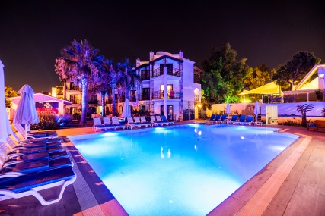

Name : Otium Park Ayaz Aqua Beach Hotel
Category : 4 Star Hotel
Address : Asarlık Mevkii Metin Akman Sk. No: 4 Gümbet/Bodrum
48400
Telephone : 0 (252) 319 32 38 / 33
Web : www.ayazaqua.com
E-mail : info@ayazaqua.com
Accommodation : All Inclusive

 Otium park ayaz aqua beach hotel
 otiumparkayazaquahotel

Distances

Nearest airport : Milas Bodrum Airport (IATA: BJV) Distance to airport : 39 km (approx. 40 min.)
Distance to city center : 3 km (approx. 8 min.) Distance to beach : 100 meters
Bodrum Castle : 5 km
Antique Theater : 3,6 km
Mausoleum : 3,8 km
Myndos Gate : 3 km
Pamukkale : 272 km
Ephesus : 173 km

Hotel Info

Hotel Building : Three block with three floors
Elevator : No
Built 2002
Latest Renovation : 2018 (all bathrooms are renovated)
Total number of rooms 190
Reception

Reception : 24 hours
Car Parking : Free
Check in : 14:00
Check out : 12:00

Exchange Service : √
Luggage Room : √
Wake Up Service : √
Safe Box : Free in the rooms
Credit Cards : Visa, MasterCard,
Taxi : In front of the hotel
Minibus : 5 min walking distance
Pets : Not allowed
Wi-Fi : Free

Accommodation

NAME OF ROOM TYPE | STANDART ROOM POOL VIEW
MINIMAL OCCUPATION | 2
MAXIMUM OCCUPATON | 2
SIZE IN SQUAREMETRES | M2: 24
NAME OF ROOM TYPE | LARGE ROOM
MINIMAL OCCUPATION | 2
MAXIMUM OCCUPATON | 4
SIZE IN SQUAREMETRES | M2: 26
NAME OF ROOM TYPE | STANDART ROOM GARDEN VIEW
MINIMAL OCCUPATION | 2
MAXIMUM OCCUPATON | 3
SIZE IN SQUAREMETRES | M2: 24
NAME OF ROOM TYPE | SWIM UP ROOM
MINIMAL OCCUPATION | 2
MAXIMUM OCCUPATON | 4
SIZE IN SQUAREMETRES | M2: 26

Food & Beverage

All local alcoholic and non-alcoholic drinks are free between 09:00 – 23:00.

Breakfast : 07:00 – 10:00 (Open Buffet)
Lunch : 12:30 – 14:30 (Open Buffet)
Snack : 11:00 – 17:00 (Open Buffet 5 kinds of products )
Dinner : 19:00 – 21:00 (Open Buffet)
Bar : 09:00 – 23:00

LARGE / SWIM UP ROOM STANDART ROOM GARDEN VIEW STANDART ROOM POOL VIEW
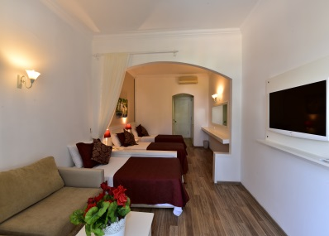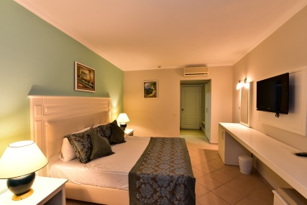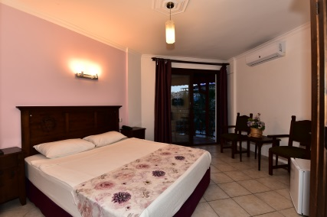

Swimming Pools

Swimming Pool  Kid’s Pool Pool Hours  Waterslıde | : 4  : 2  : 09:00 – 18:00  : 10:00-12:00 / 14:00-16:00
WC | : √
Showers | : √
Sun Beds | : √
Parasol | : √

Sports and Facilities

BILJART : √ ONE HOUR 5 EUR
TABLE TENNIS : √ DEPOZIT 5 EURO

REMARKS & OTHER FACILITIES + COSTS POOL VOLLEYBALL

Other Services and Facilites

Sauna : Extra Charge
Laundry : Extra Charge
Transfers : Extra Charge
Doctor : Extra Charge

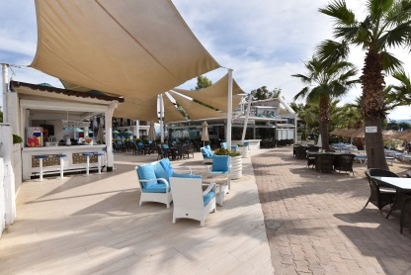
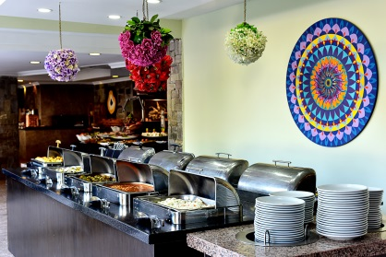
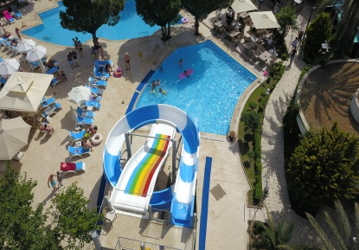

NOT: İnternet Wireless : (free) User name : passport number
Password : room number

* If you want to have a lunch box please order the reception untıl 6 o’clock pm

AVAILABLE EXTRAS (PAYABLE LOCALY)

Beach Towels : Deposit (5 EURO / 5 USD)
Pier Entrance :10EURO (Per Person)

*imported drinks ,bottle of wine ,bottle of water
after 23:00 O’clock all drinks

*ROOM İNFO: Make sure the balcony door is closed before turning on the Air CO. Otherwise Air CO will not work.
When you leave the room, press the doorknob to lock the door.

